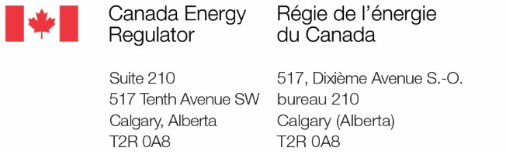

[Company name]
[Project name]
Notice of Proposed Abandonment
Subsection 241(1) of the Canadian Energy Regulator Act

On [date application was filed], [Company name] has filed an application with the Commission of the Canada Energy Regulator (Commission) to abandon the [pipeline/facility name] pursuant to subsection 241(1) of the Canadian Energy Regulator Act.

The proposed abandonment will involve [description of pipeline/facility] located [in/between, as appropriate] as shown on the accompanying map. You can find the application on the Canada Energy Regulator’s (CER’s) website here [CER Filing ID number – with hyperlink – from the email receipt received upon filing the application].

The Commission expects [Company name] has consulted with those who may be potentially affected by an abandonment project to discuss the project activities, abandonment method, mitigation measures, and the discontinuation of service. Information on the Commission’s expectations of engagement can be found in Guide B of the Filing Manual
(www.cer-rec.gc.ca/FilingManual).

[Include this sentence for service; exclude for publication: You are receiving this notice because you may be affected by the abandonment project.] If you anticipate that your lands, rights or interests may be adversely affected by the proposed abandonment, you may advise the Commission of your concerns about the proposed abandonment by filing a written statement of opposition or a request for a hearing within thirty (30) days of [if published, then date of publication; if served, then date of service]. The written statement of opposition or request for hearing must set out the nature of your interest and concerns in relation to the proposed abandonment. A form to use for your statement of opposition or request for a hearing is attached and can also be found at Templates for public participation. Part F of the form includes information on filing your statement of opposition/request for hearing form.

If a statement of opposition or request for hearing is filed with the CER, and is not frivolous or vexatious and is not withdrawn, then the Commission will order that a public hearing be conducted in respect of the abandonment application. In establishing a hearing process, the Commission will consider the nature of the application and the content of any statements of opposition or requests for hearing it receives.

Alternate Dispute Resolution (ADR) services – such as mediation and facilitation – are available from the CER to help parties resolve disputes outside of the Commission’s hearing processes. You can read more about ADR on the CER’s website at
http://www.cer-rec.gc.ca/en/consultation-engagement/alternative-dispute-resolution/.

For more information or for any questions, you can contact the CER’s Land Matters Advisory Service at 1-800-899-1265 (toll free) or via email at LMAS@cer-rec.gc.ca.

